Name: William A. Brannon

Assignment: Lab Assignment Report #2

Date Due: Monday, February, 4, 2019

Class: Fundamentals of Programming III Section #1

**Exercise**

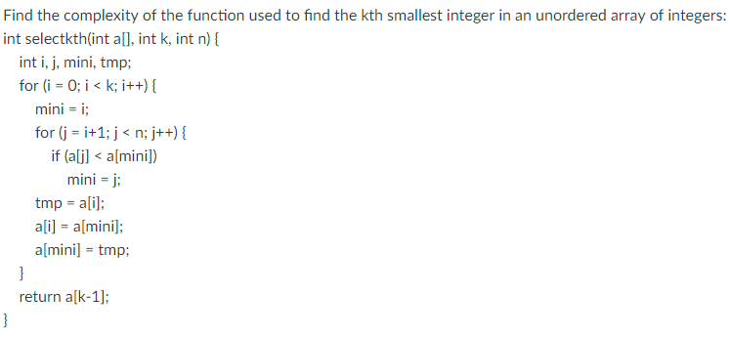

**Answer to Exercise**

The outer loop does k iterations of the inner loop. The inner loop does n-1 iterations of its processes. Thus, the general complexity would be O(k(n-1)). K can be any value greater than 0 and less than or equal to N. Thus, simplifying the answer to its upper bounds, it would be O(n^2-n). Big O notation is only concerned with the most significant term which would lead to O(n^2).